A Database Mini Project Report
on
“Tourism Management System”

Submitted to the
Savitribai Phule Pune University
In partial fulfillment for the award of the Degree of
Bachelor of Engineering
in
Information Technology
by
Ajinkya Kulkarni-33126
Yash Kulkarni-33129
Shubham Loya-33133
(Exam Seat No. / Roll No. & Division)

Under the guidance of

Prof. S A Jakhete


Department Of Information Technology
Pune Institute of Computer Technology College of Engineering
Sr. No 27, Pune-Satara Road, Dhankawadi, Pune - 411 043.

2019-2020

CERTIFICATE

This is to certify that the mini project report entitled “Tourism Management System” being submitted by Ajinkya Kulkarni(33126) , Yash Kulkarni(33129) , Shubham Loya(33133) is a record of bonafide work carried out by him/her under the supervision and guidance of Prof. S A Jakhete in partial fulfillment of the requirement for TE (Information Technology Engineering) – 2015 course of Savitribai Phule Pune University, Pune in the academic year 2019-2020.

Date: 16/10/2019

Place: Pune

Guide Subject Coordinator Head of the Department

Principal

This Project Based Seminar report has been examined by us as per the Savitribai Phule Pune University, Pune requirements at Pune Institute of Computer Technology, Pune – 411043 on . . . . . . . . . . .

Internal Examiner External Examiner

ACKNOWLEDGEMENT

The success and final outcome of this project required a lot of guidance and assistance from many people and I am extremely privileged to have got this all along the completion of my project. All that I have done is only due to such supervision and assistance and I would not forget to thank them.

I owe my deep gratitude to our project guide Prof. S A Jakhete, who took keen interest on our project work and guided us all along, till the completion of our project work by providing all the necessary information for developing a good system..

I respect and thank Prof, A M Bagade (HOD IT), for providing me an opportunity to do the project work in PICT DBMS LAB and giving us all support and guidance which made me complete the project duly. I am extremely thankful to him for providing such a nice support and guidance, although he had busy schedule managing the corporate affairs.

I am thankful to and fortunate enough to get constant encouragement, support and guidance from all Teaching staffs of IT Department which helped us in successfully completing our project work. Also, I would like to extend our sincere esteems to all staff in laboratory for their timely support.

Ajinkya Kulkarni Yash Kulkarni Shubham Loya

CONTENTS

Sr.No | TITLE | Page no
1. | Content’s Abstract | 3
2. | Introduction | 3
3. | Overview | 4
4. | Background and Motivation | 4
5. | Methodology | 4
6. | Scope | 4
7. | Requirements | 4
8. | E-R Diagram | 6
9. | Schema Diagram | 6
10. | Relational Database Design | 7
11. | Database Normalization | 8
12. | Graphical User Interface | 16
13. | Conclusion | 17
14 | Refrences

1.ABSTRACT

In this project we have created a user-friendly website for tours and travels agency. For this application we used the backend as MySQL to store the data which is used in the website and for the user interface, we have used HTML, CSS and JavaScript along with JSP for linking the backend. Two kinds of user are able to use this website which are Admin and the customer.The Admin can perform all the CRUD operations which are insert,update,delete,view.Admin can add ,delete customer as well as package and its respective attributes.Customer can login on the website by registering himself and can view and book the package added by the admin.
2. INTRODUCTION

In this Tourism Management System, the site will be able to present viewer all related information about the travel website as a normal website on the internet,

At the same time it also allows travel agency to manage their database. The system will not onlya good marketing tool but also a good management tool.

3. Overview: -

This report discusses the result of the work done in development of "Tourism Management System" on “JSP” Front-end Platform and “MySQL” as back-end Platform.At the development of an application JSP provides good connecting
facility between all pages, also the back-end MySQLis most important to save all the data related the application.

3.Background and Motivation

The definition of our problem lies in manual system and a fully automated system.

Manual system: Currently all travel agencies have their own websites so user has to go to the individual agency website.
It is very time consuming and inefficient. If user wants detailed information about the
Package or dates then he has to go and visit the particular travel agency. Detailed information of packages may not be available on dynamic manual pages.
.
Technical system: In this web based system, it will be able to present viewer all related information about the travel agency as a normal website in the internet and at the same time allow management tasks to be done on the system.
Viewers will have an easy accessibility to all information of the travel agency.
The currently used Tourism Management System is the best suitable for the web
pages on a computer system.

4. Objective

Need of Tourism Management System

1) Efficient
2) Convenient
3) Reliable
4) Accurate
5) User-Friendly

The Objective of this project is to develop a system that automates the process and activities of the travel agency and its customers.

5. Methodology

To implement the above goals, the following methodology needs to be followed:

1. Specifying the Application and various components of the Architecture.
2. Specifying the bindings between the tasks and the resources either manually or by the design
Tools.
3. Specifying the port interconnections between the resources.

Dynamic growth of tourism business requires creation of new project attractive packages of services with corresponding quality and quantity. Expedient and relevant issue is the design and implementation of efficient and successful projects of socio–economic and innovative character in tourism, which need special methodology.
The basis of the methodology of project management in tourism is the analysis of the needs of tourists in the target market and capabilities of tourist operator to satisfy them through Tourism management system.

It was concluded that the methodology of project management implies consistent and interconnected implementation of the functions of management of tourism activity by the use of methods, tools, techniques and methodology of research in tourism. Management of tourism projects requires taking into account the features of tourist services with regular fluctuations in demand, changes in space and time, inseparability from the source (destination) and the impossibility to store.

SCOPE OF PROJECT

Tourism Management System is an integrated software developed for tour operating companies. The main aim of this project is to help the tourism companies to manage their customers. It makes all operation of the tour company easy and accurate. The standalone platform makes tourism management easy by handing agencies requests and providing servers for the customers located at different parts of the various cities. Different modules have been incorporated in this project to handle different parts and sector of the tour management field.

REQUIRMENTS

We are going to perform this project on a Windows based platform so we need the Operating System as Windows. Any version of Windows such as XP and above. The system should have minimum of 576.2MB RAM as well as 15GB of minimum storage capacity. The system should be pre-installed with the server software named as “XAMPP” standard. And JSP version ---- or above. First, we have to install both software and we have to do connectivity between them by changing the configuration file.

ER-Diagram-:

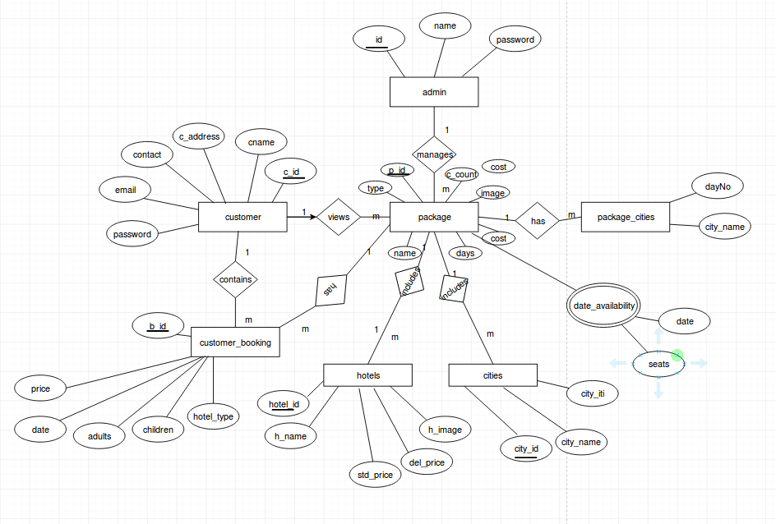

Schema Diagram-:

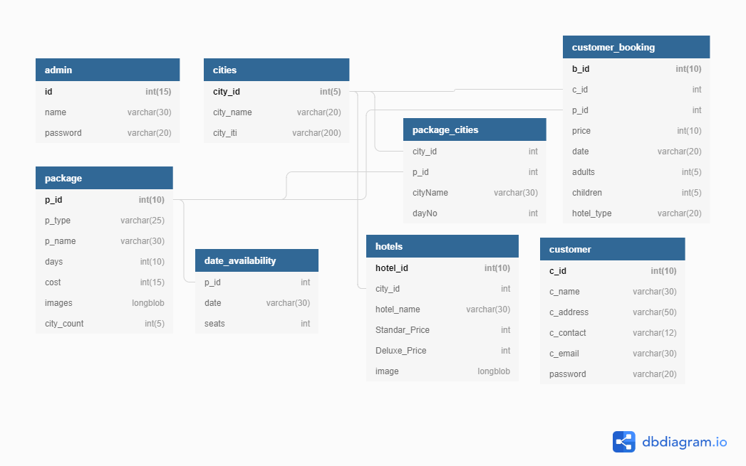

7. RELATIONAL DATA BASE DESIGN

1]Admin:-

Admin id, name, password

id | name | password

2] Customer:-
Customer id, name, address ,contact, email, password
c_id | c_name | c_address | c_contact | c_email | password

3]Package:-

Package id, type, name, days, cost, images, city_count

p_id | p_type | p_name | days | cost | images | city_count

4]package_cities:-

Package_cities package id, city id, day no. , city name

p_id | city_id | dayNO | cityName

5]hotels:-

Hotels hotel id, hotel name , city id , standard price , delux price , hotel image
hotel_id | hotel_name | City_id | Standard_price | Delux_price | Hotel_image

6]date_availability:-

Date_availability package id, date , seats
p_id | date | seats

7]Customer_Booking:-

Booking id, customer id , package id , price , date ,adults ,children, hotel_type
b_id | c_id | p_id | price | date | adults | children | Hotel_type

8]cities:-

City id , city name, city itinerary
city_id | City_name | City_iti

8. Database Normalization:
First Normal Form:-

The relation is in 1NF if it has no repeating groups. All tables has no repeating groups so they are in 1NF.

Tables:-

1]Admin:-

Admin id, name, password

id | name | password

Second Normal Form

A relation is said to be in second normal form if it is already in first normal form and it has no partial dependency

Tables:-

1] Customer:-
Customer id, name, address ,contact, email, password
c_id | c_name | c_address | c_contact | c_email | password

Third Normal Form

A relation is said to be in third normal form if it is already in 1st and 2nd NF and has no transitive dependency.

Tables:
1]Package:-

Package id, type, name, days, cost, images, city_count

p_id | p_type | p_name | days | cost | images | city_count

GRAPHICAL USER INTERFACE

Our application has an user friendly platform that uses a GUI interface which has been implemented in JSP and HTML to establish communication with the user. We’ve also implemented various features which are self-explanatory. The provided forms are easy to fill in and components can be added, removed and updated very easily through a single dialog box. The various fields in the application can be filled and modified by using drop-down lists
List boxes are used to display all the components at once so that user can see all the components of a Particular type at once. One can just select the component and modify and remove the component.(based on the access control of the person)

Features

1. Clean separation of various components to facilitate easy modification and revision.
2. All the data is maintained in a separate file to facilitate easy modification
3. All the data required for different operations is kept in a separate file.
4. Quick and easy saving and loading of database file.
5.Admin can perform all the CRUD operations which increases the functionality.

Snapshots of the application

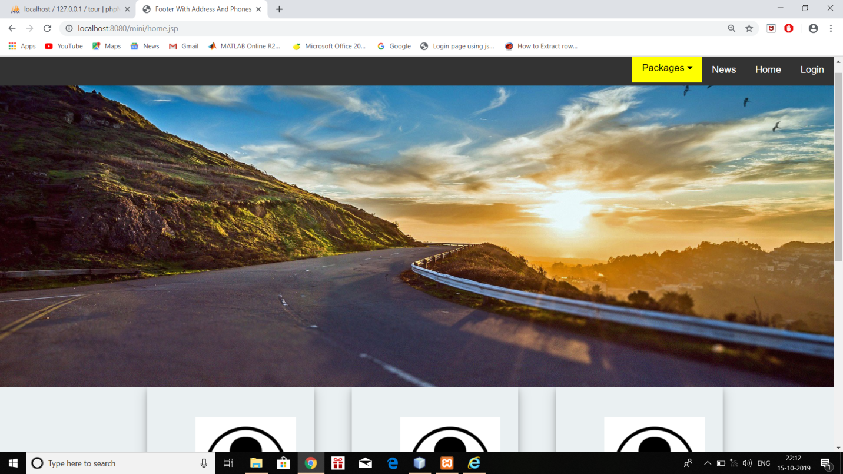

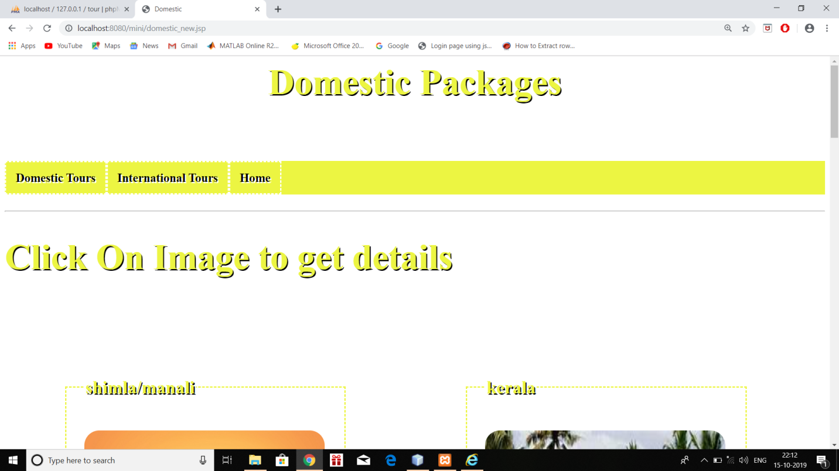

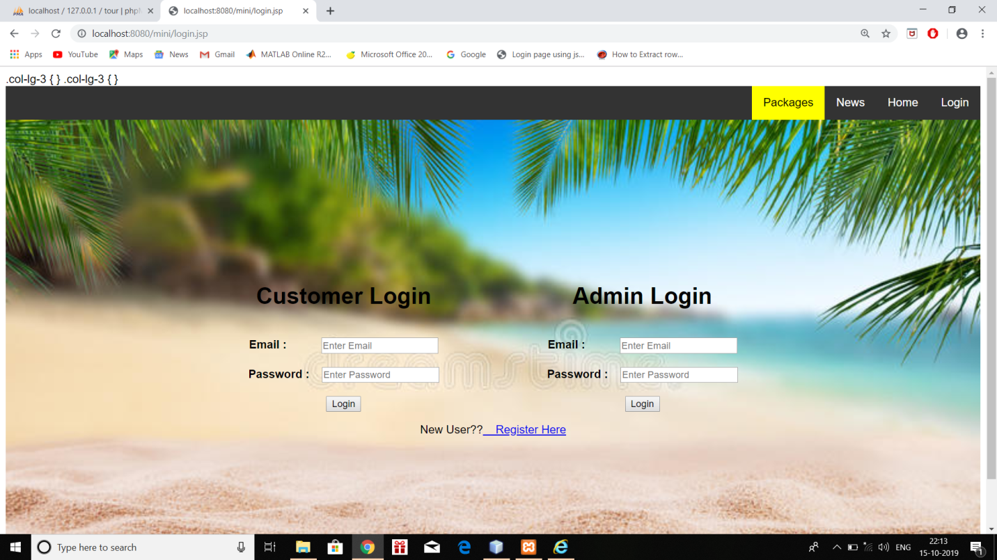

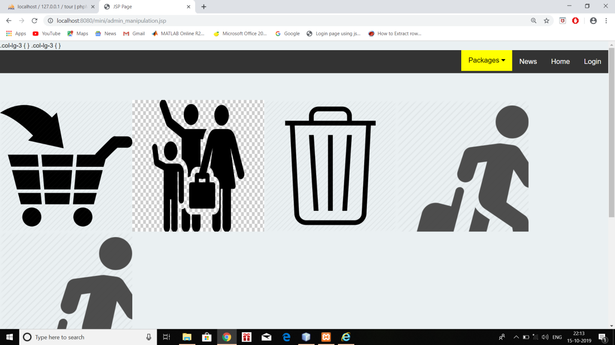

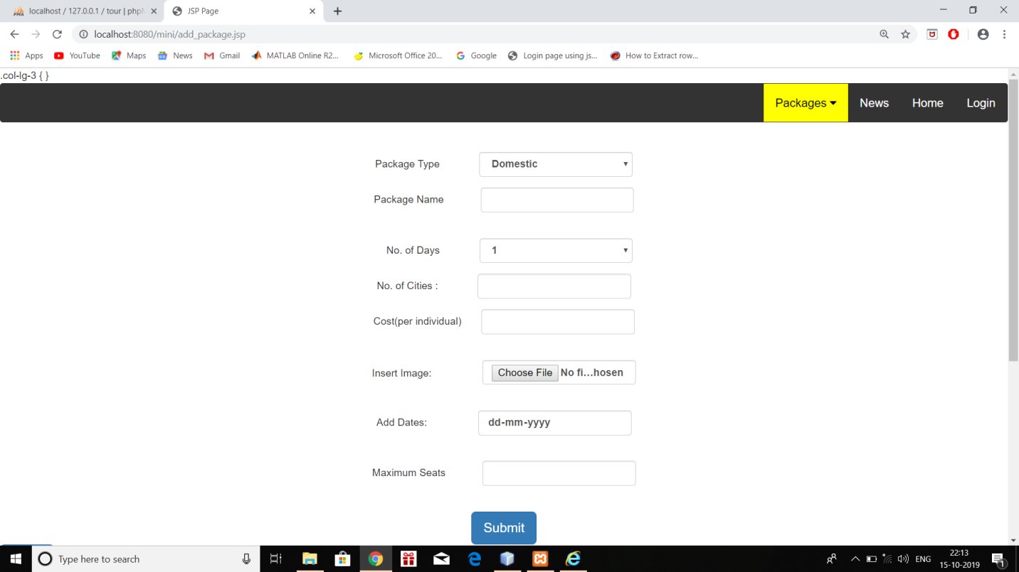

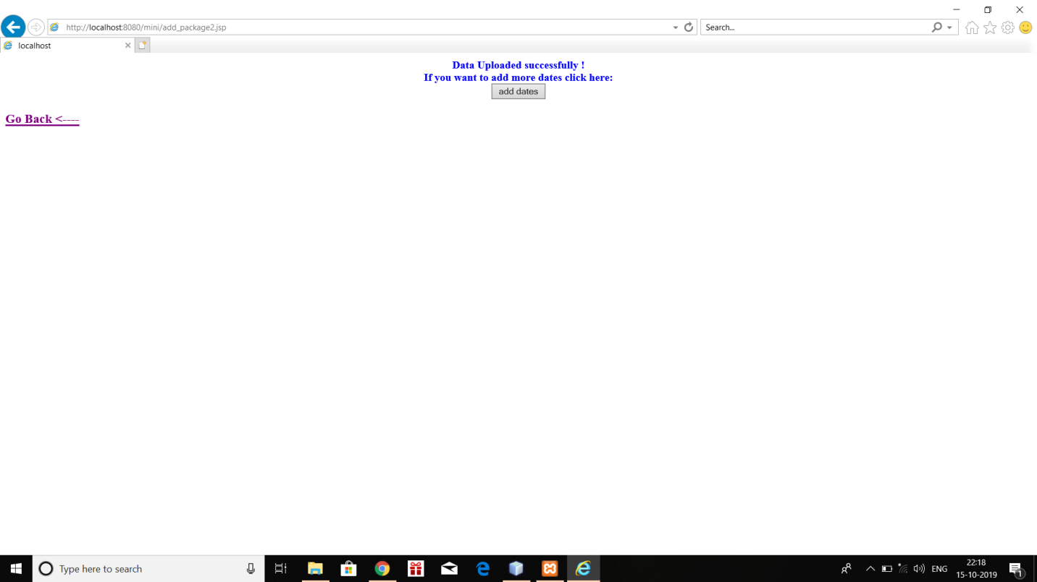

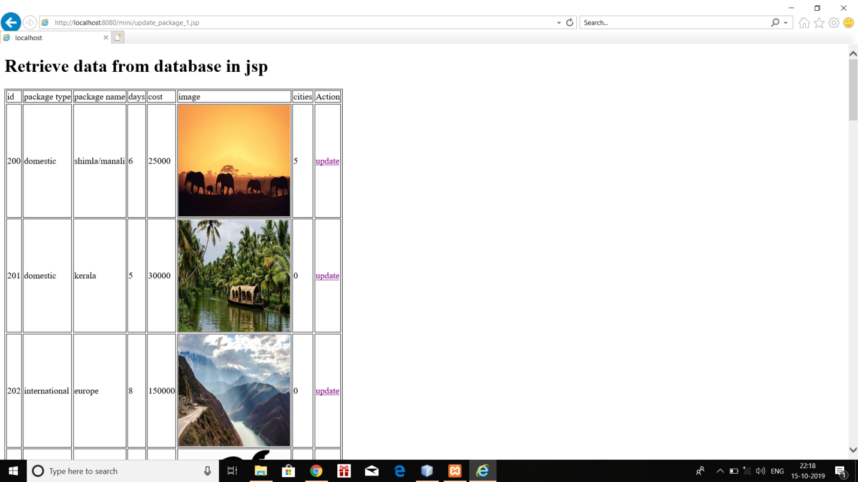

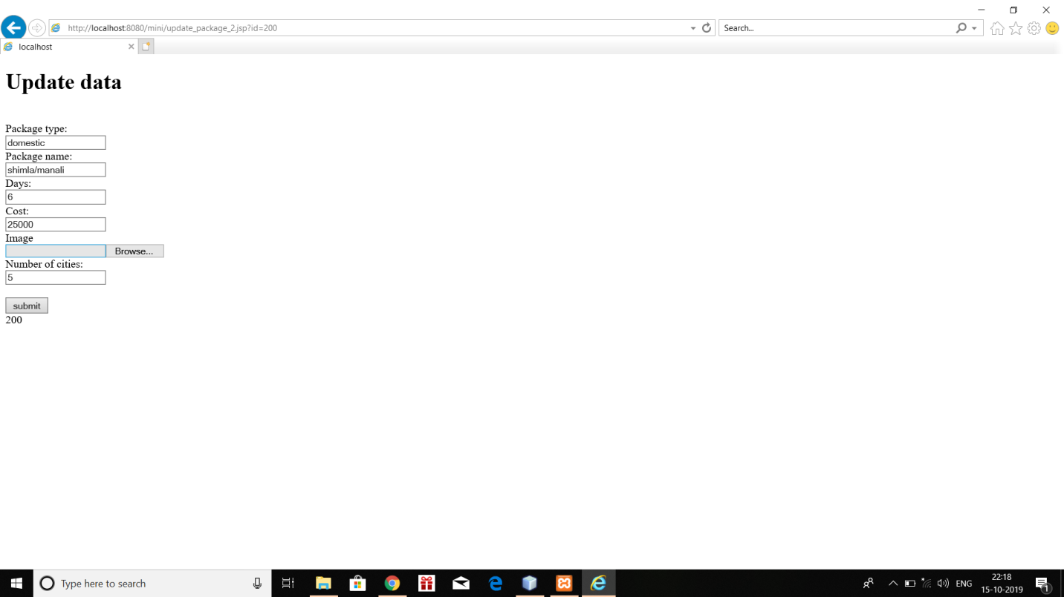

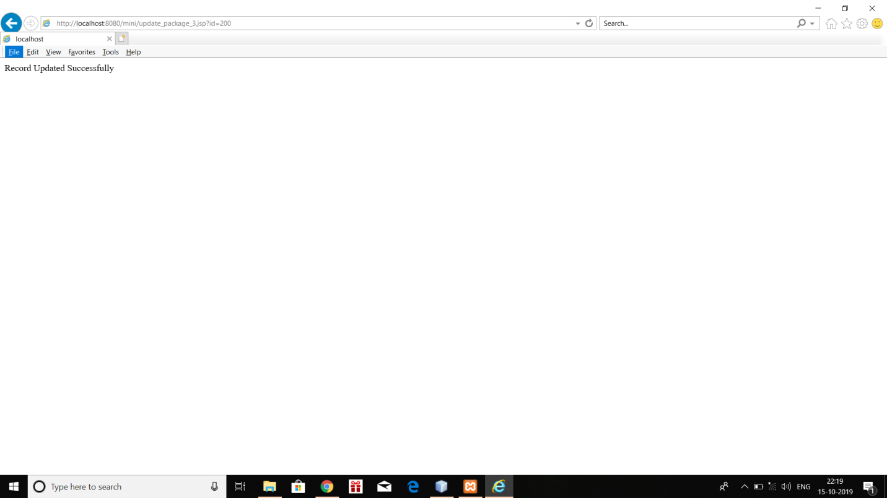

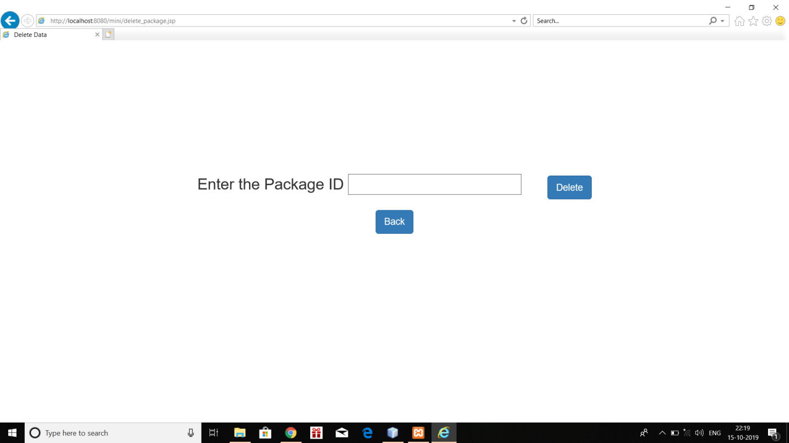

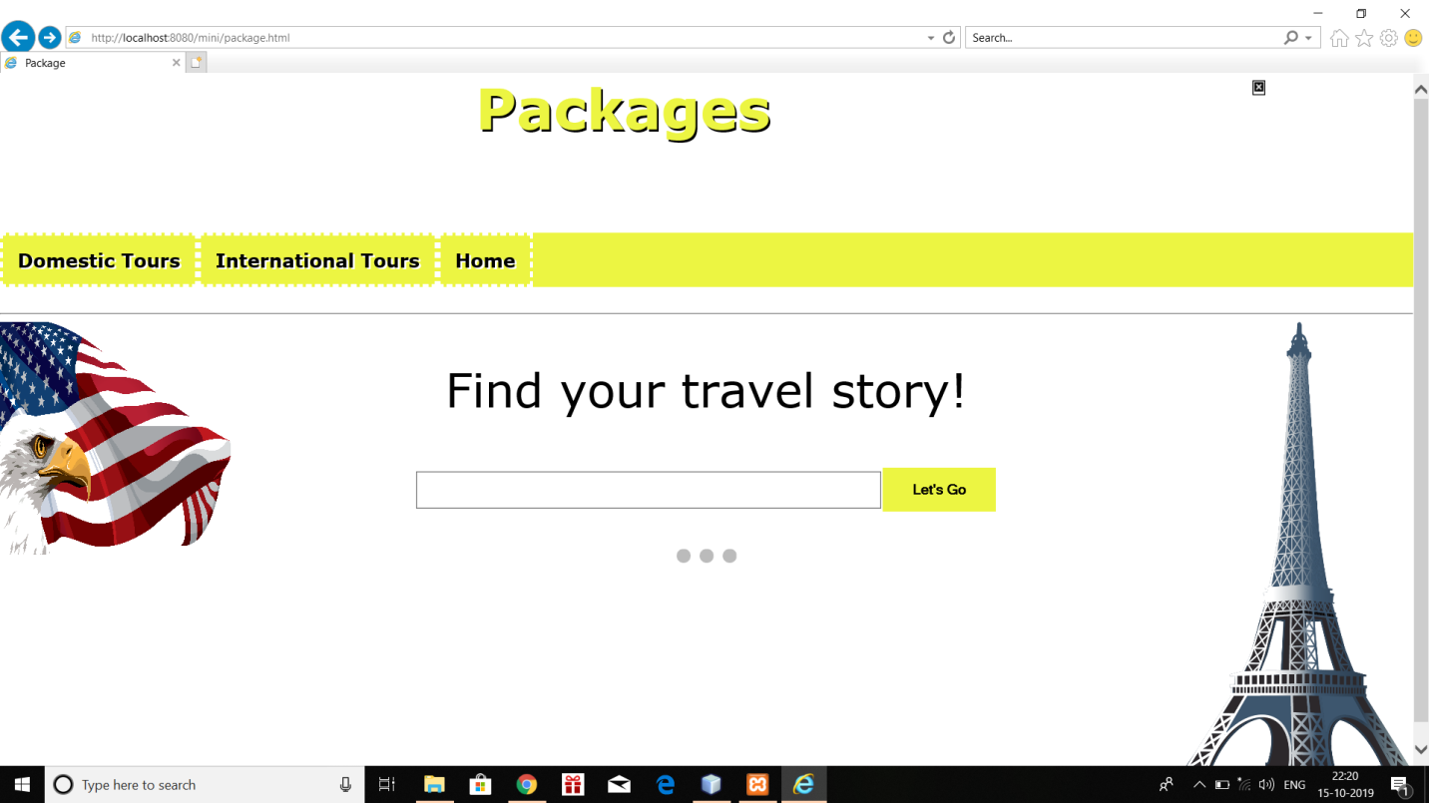

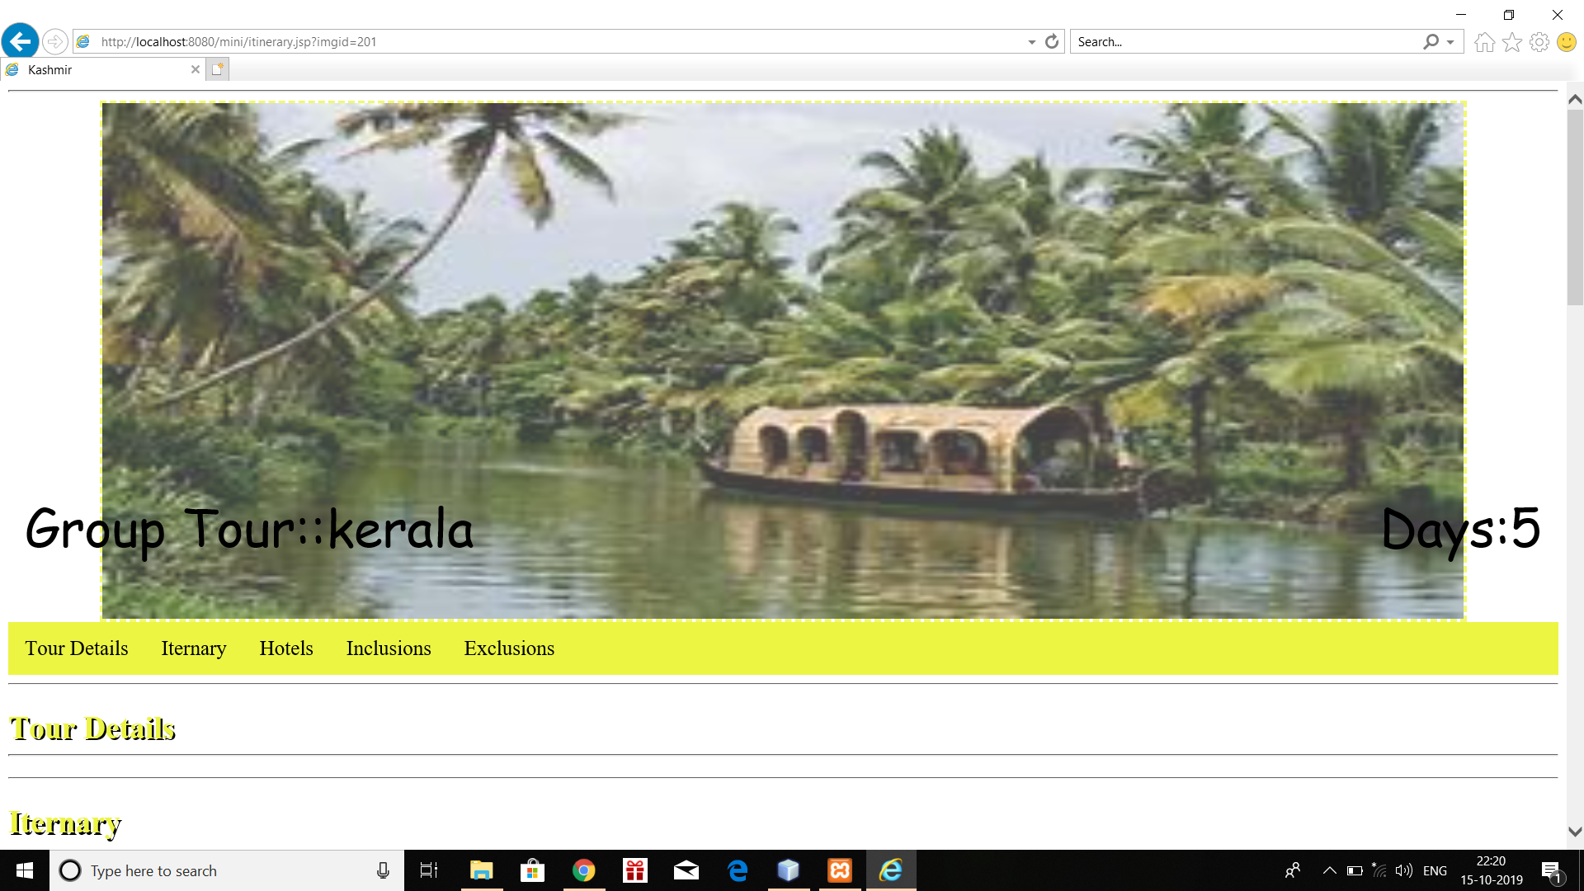

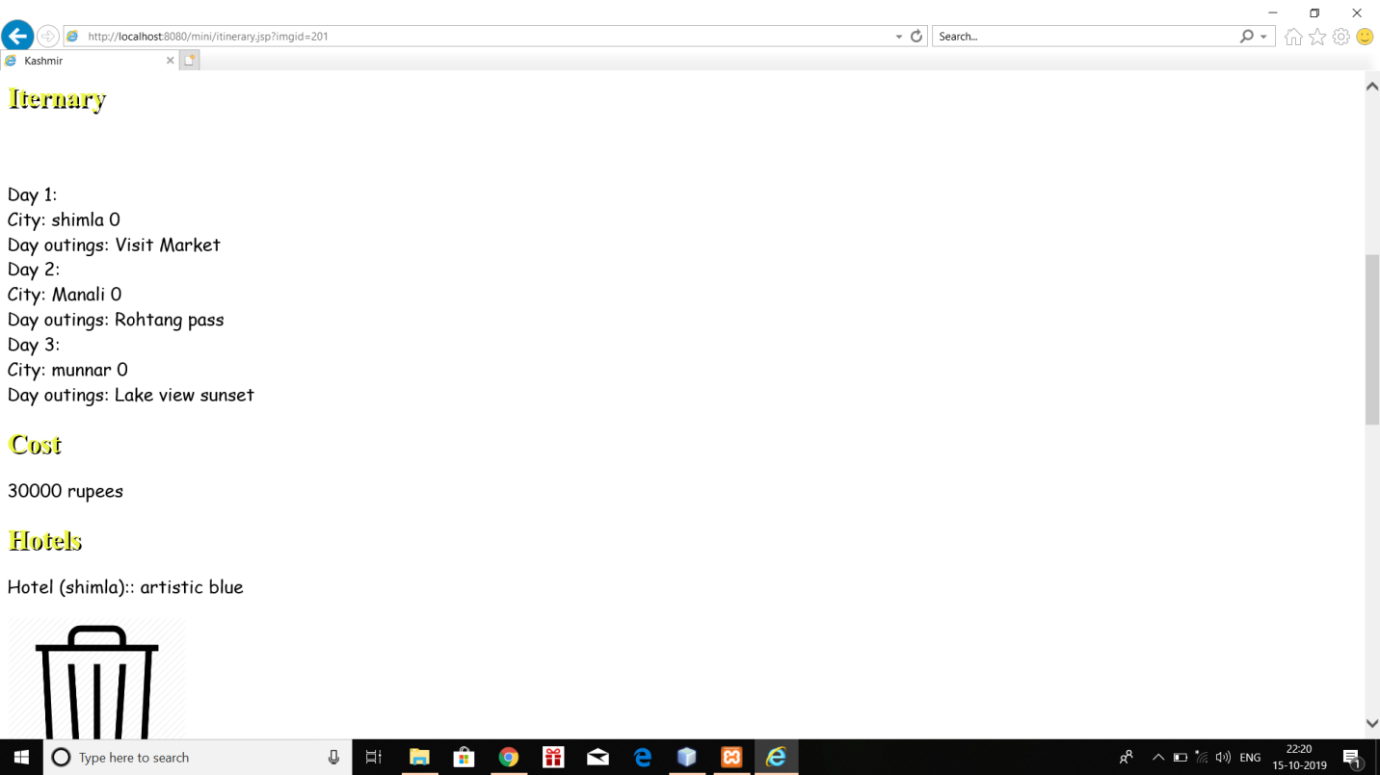

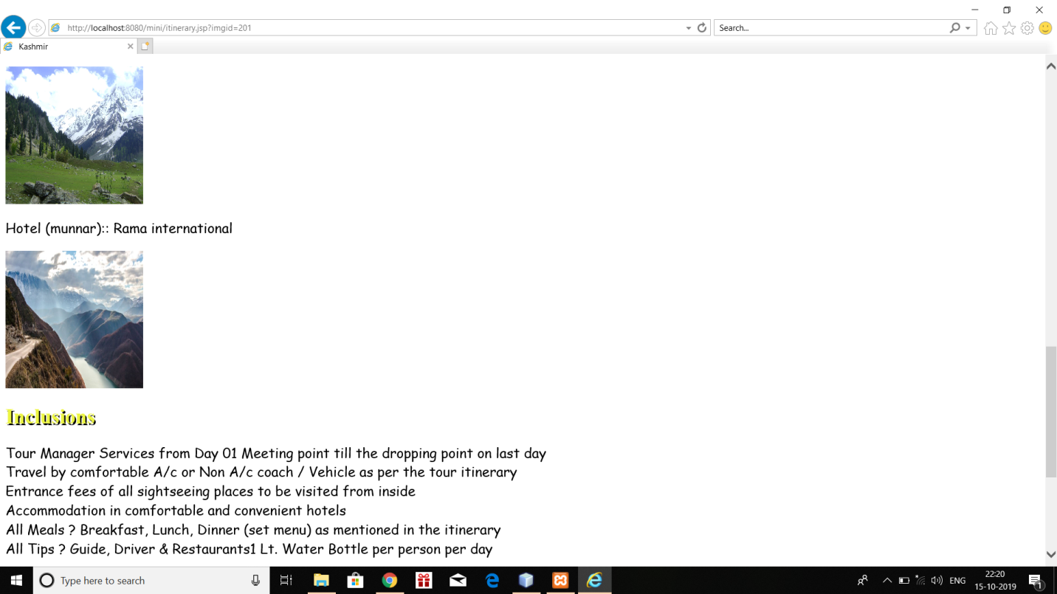

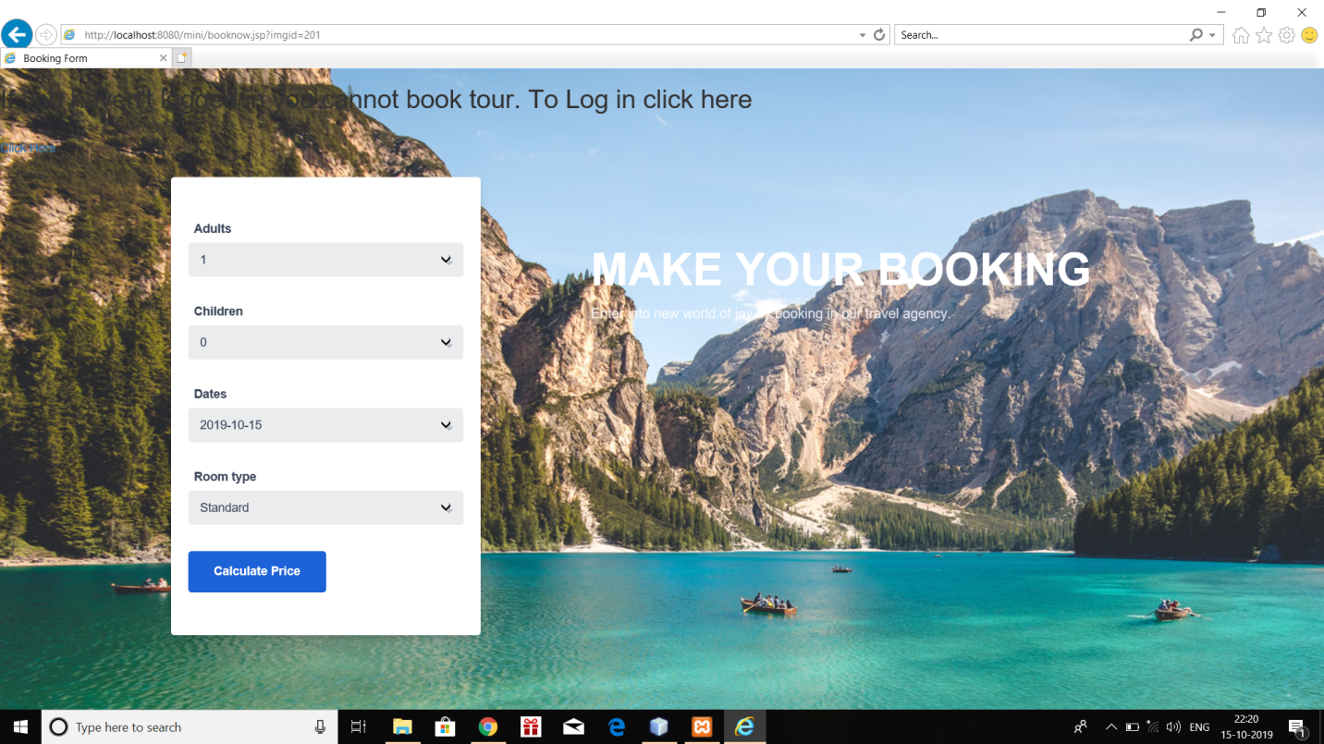

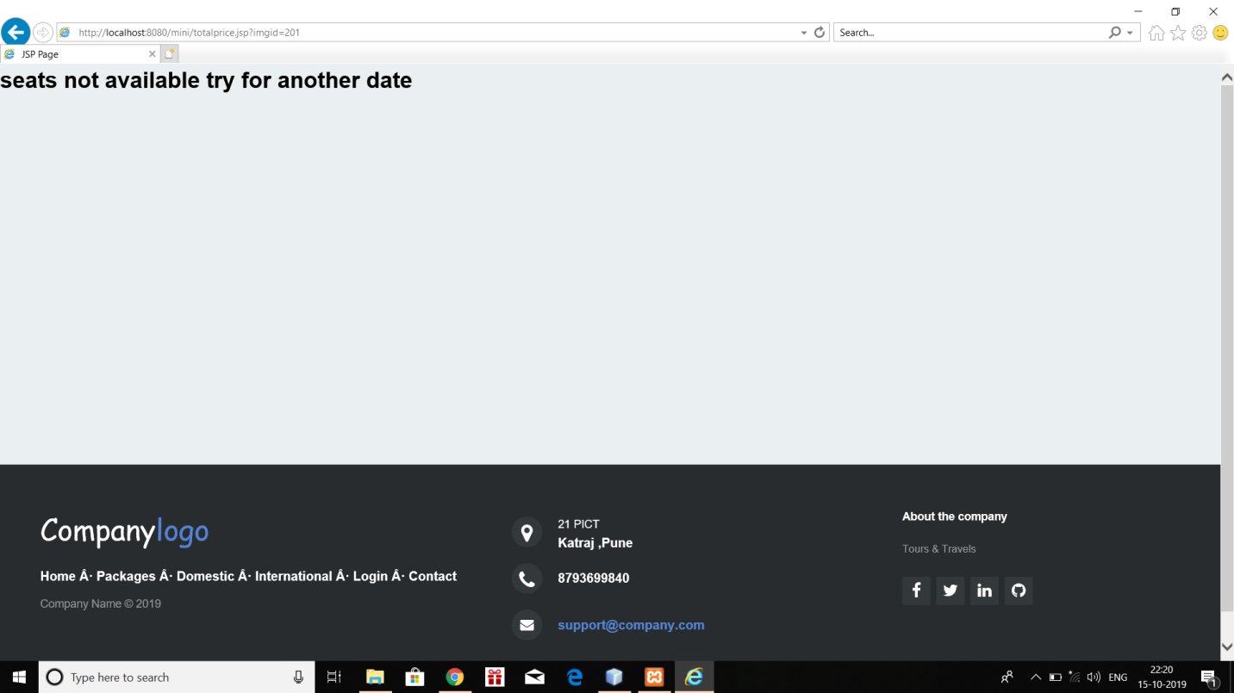

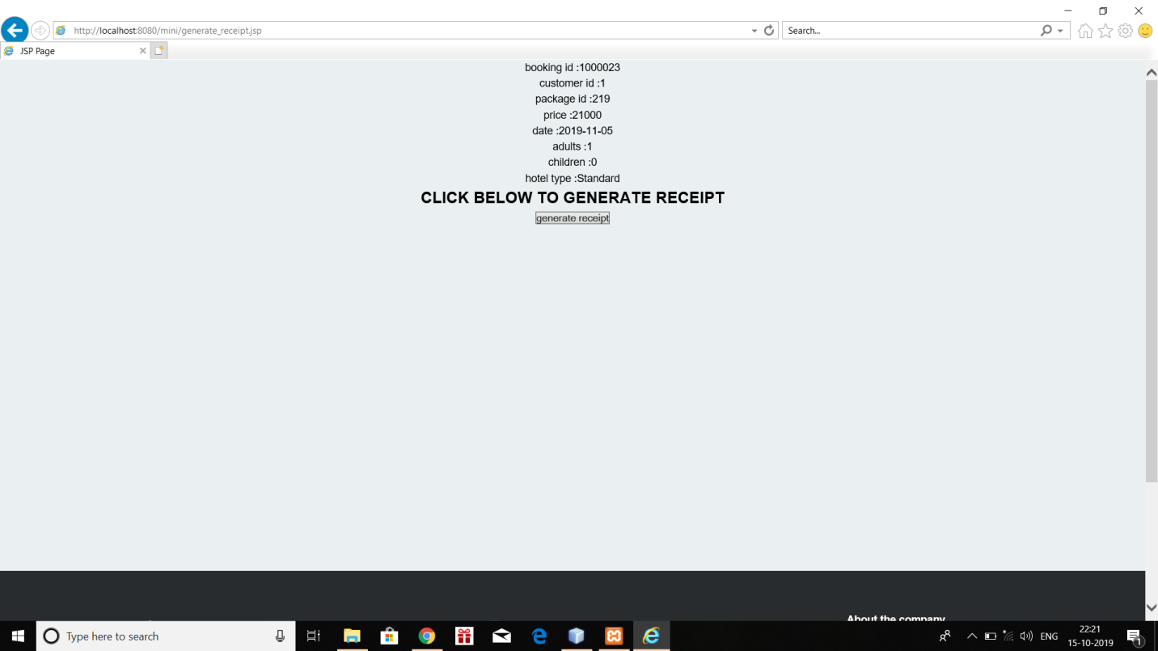

Conclusion-:
Tourism is currently recognized as a global industry which is highly growing at a high rate like other industry. There are many different activities are occurred in tour activities. My ‘Tour Management’ web based application helps in online distribution of tour packages, hotel, hotel types etc. This ‘Tour Management System’ can be fully customized with integration different API’s. It has friendly environment that connects customer willingly. Finally, I can say that this Web Based Application will help tour manager to control and handle the tour related activates effectively and efficiently.

CONCEPTS USED
1.MySQL-Database Backend
2.JSP –Front End
3.JDBC/ODBC -Connectivity
4. Triggers/PROCEDURES/etc

SOFTWARE USED
1. Netbeans
2. XAMPP LocalHost
3.Google chrome

References-:
1.W3schools.com
2.Wikipedia
3.Youtube
4.JSP official document
5.Geeks for Geeks
6.Rose India

